Exercise 1: Try to create a nested list as given below:

1. Chapter 1
   1. Section 1
      1. Topic 1
      2. Topic 2
   2. Section 2
      1. Topic 1
      2. Topic 2
      3. Topic 3
2. Chapter 2
3. Chapter 3
   1. Section 1
      1. Topic 1
   2. Section 2
   3. Section 3
      1. Topic 1
      2. Topic 2
4. Chapter 4
   1. Section 1
   2. Section 2
   3. Section 3

Exercise 2: Time-Table using table tag:

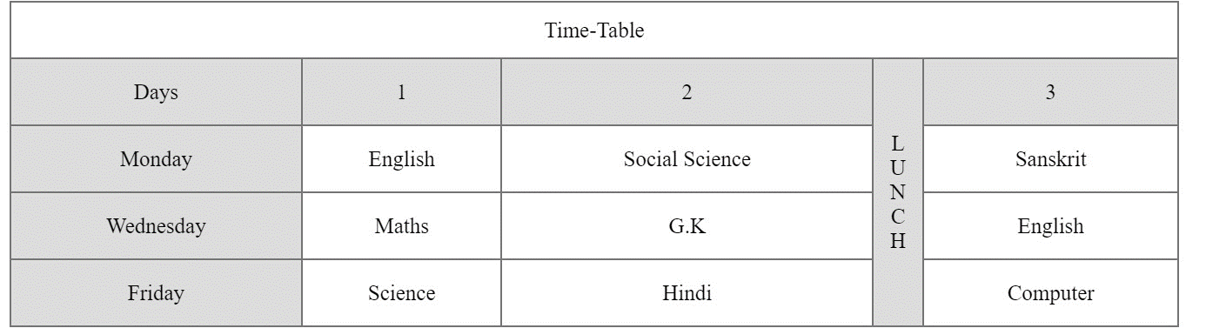

Exercise 3:  Website layout using table tag:

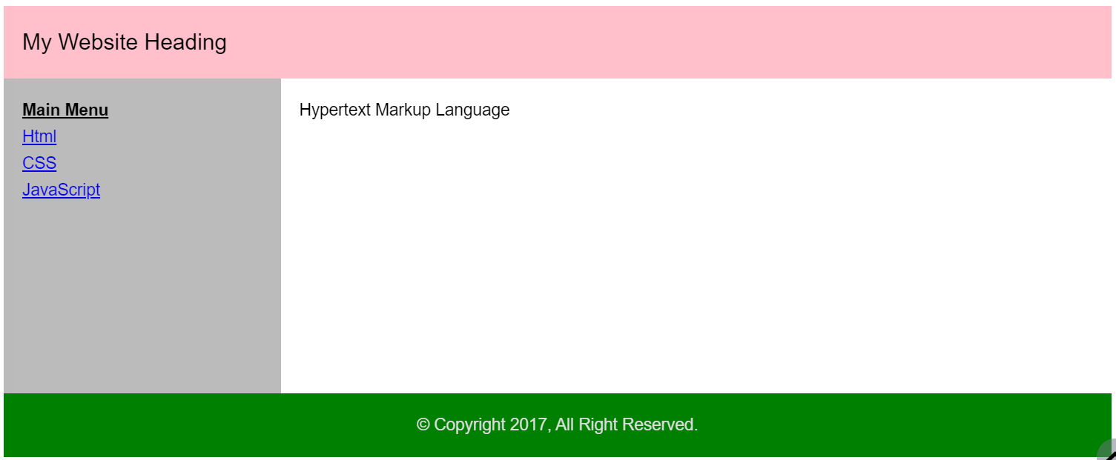

Exercise 4: Registration form using fieldset

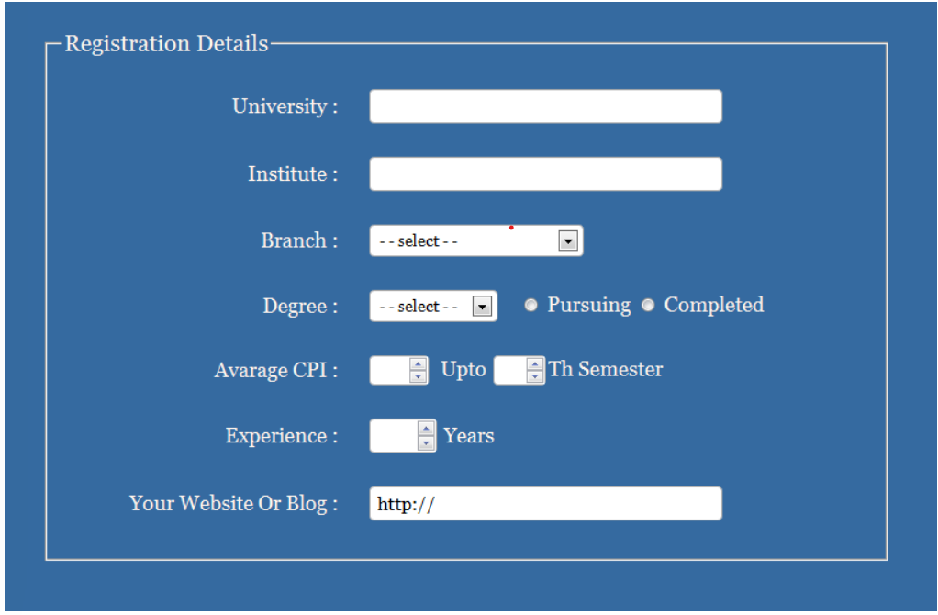

Exercise 5: Try To Create Signup Form.

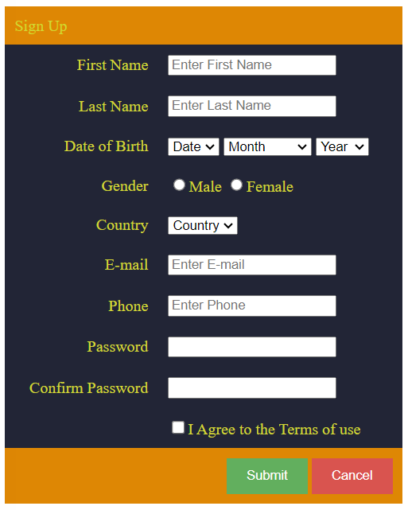

Exercise 6:Click on the News Logo to open its website.



Exercise 7:HTML basic page layout using HTML5 semantic tags.

